**DAILY ONLINE ACTIVITIES SUMMARY**

|  |  |  |  |  |  |  |  |  |
| --- | --- | --- | --- | --- | --- | --- | --- | --- |
| **Date:** | **08/06/2020** | | | | | **Name:** | **PONICA.J** | |
| **Sem & Sec** | **4TH & B** | | | | | **USN:** | **4AL18CS055** | |
| **Online Test Summary** | | | | | | | | |
| **Subject** | | **MATHEMATICS** | | | | | | |
| **Max. Marks** | | **30** | | **Score** | | | **22** | |
| **Certification Course Summary** | | | | | | | | |
| **Course** | **WEBINAR** | | | | | | | |
| **Certificate Provider** | | | **IIDE** | | **Duration** | | | **11.30AM -1.00PM** |
| **Coding Challenges** | | | | | | | | |
| **Problem Statement:** C Program to Generate All the Set Partitions of n Numbers Beginning from 1 and so on | | | | | | | | |
| **Status:EXECUTED** | | | | | | | | |
| **Uploaded the report in Github** | | | | | **YES** | | | |
| **If yes Repository name** | | | | | **https://github.com/ponica-jaya/LOCKDOWN-CODING.git** | | | |
| **Uploaded the report in slack** | | | | | **YES** | | | |

Online Test Details: (Attach the snapshot and briefly write the report for the same)

TODAY I HAD TEST ON THE SUBJECT MATHS WHICH WAS HELD AT 9.30AM TO10.10AM WHICH WAS FOR 30MARKS AND I HAVE ATTACHED MY RESULT SNAPSHOT BELOW.

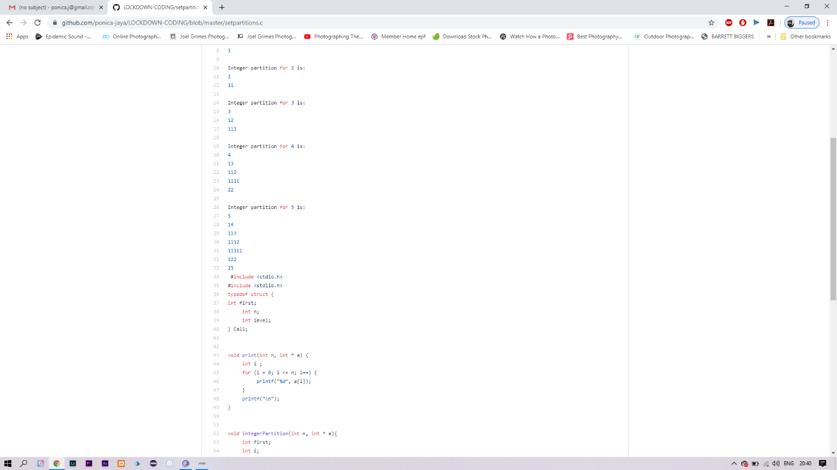

Certification Course Details: (Attach the snapshot and briefly write the report for the same)

TODAY FROM 11.30AM TO 1.00PM I HAD A WEBINAR CONDUCTED BY IIDE ON E COMMERCE AND I HAVE ATTENDED IT THROUGH ZOOM APP AND HENCEFORTH ATTACHED THE SNAPSHOT OF IT.



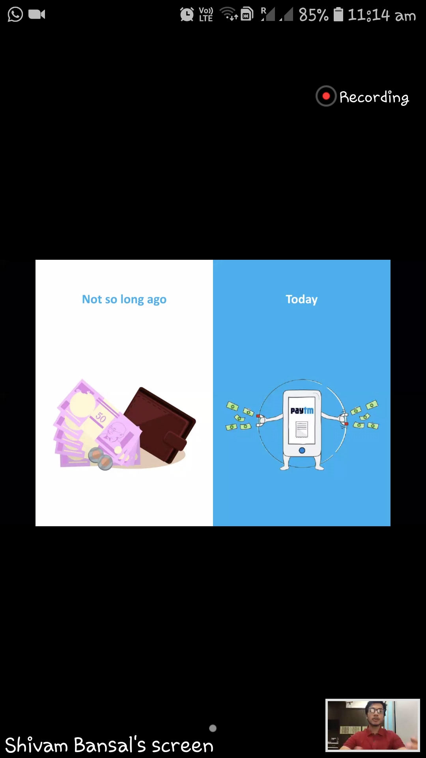

Coding Challenges Details: (Attach the snapshot and briefly write the report for the same)

TODAY I HAVE GOT A C PROGRAM FROM MY TEACHERS

C Program to Generate All the Set Partitions of n Numbers Beginning from 1 and so on

SOLUTION HAS BEEN UPDATED IN MY GITHUB ACCOUNT



THIS IS THE SNAPSHOT OF TODAYS PROGRAM CODE